Day 3 –> Hands-On Exercises

# Task 1

Create a pipeline called: Testing_Pipeline  
Map 3 fields (use a mapper snap to achieve this):

1. **Key Name**: “Full_Name”  
   **Value**: <Your Name>
2. **Key Name**: “City”  
   **Value**: <City where you were born>
3. **Key Name**: “Company”  
   **Value**: <Hardcode the value “IWConnect”>
4. **Key Name**: “Date”  
   **Value**: <Today’s date>Function

Question:

Can you map multiple records in 1 mapper?

# Task 2

Continue on the same pipeline from Task 1.

1. I want to divide the 4 fields in 2 objects.  
   Move the “**Full_Name**” field and the “**Date**” field in an object called “**Employee**”  
   Move the “**Company”** field and the “**City”** field in an object called “**Region”**

The output should look something like this:

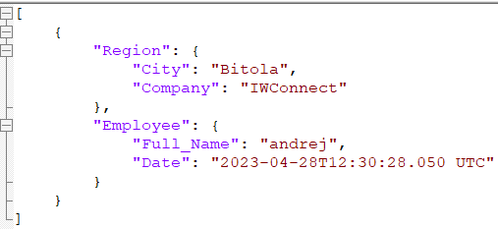

# Task 3

Achieve the following transformations

1. We don’t want the date to be a full timestamp. Please change this to a **date** format only
2. Additionally, the client is requesting to add the country next to the city name. Please add the following string “_Macedonia” next to the city value. (use a function to achieve this)

# Task 4

In this step you need to add two things:

1. Write the output in a json file called “Testing_Day3.json”
2. Before we write the output to a field we need to check and make sure the company has a value of “IWConnect”

Question:  
What happens if we switch the check from the value “IWConnect” to “InterWorks”. Will the file be written?